Case 1-Bulgaria-Neolithic-Ceramic-Figurine-Abstract-VI Millennium BCE- Stara Zagora-92 mm

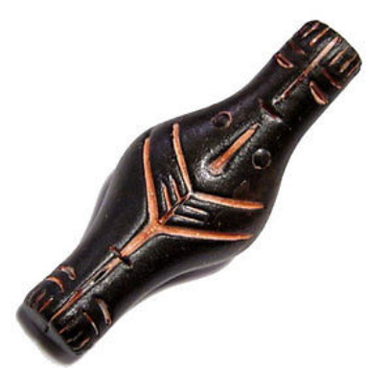

**Size: 92/37mm;                Weight: 28 g;**